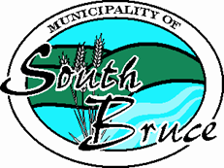Corporation of the Municipality of South Bruce

**Report Title: 2022 Cash in Lieu of Parkland Reserve Statement**

**Prepared By:** Kendra Reinhart, Treasurer

**Department:** Finance

**Date:** Jan 19, 2023

Section 42 of the Planning Act states that a Municipality may require, as a condition of development, that land be conveyed to the municipality for a park or other public recreational purposes. Alternatively, the Council may require a payment in lieu, to the value of the land otherwise required to be conveyed.

These funds must be held in a special account (reserve fund), allocated interest, and spent only for the acquisition of land to be used for a park or other recreational purposes, including the erection, improvement or repair of building and the acquisition of machinery for park or other recreational purposes.

The Treasurer of the municipality is required to report annually, a statement of Cash in Lieu of Parkland Reserve Fund, and the Statement shall be posted on the Municipality’s website.

Balance of Funds at January 1st, 2022 $33,798.37

Add Cash in Lieu of Parkland funds collected in 2022 $ 7,970.03

Add interest earned for 2022 $ 841.18

___________

**Balance at December 31st, 2022 $42,609.58**

Respectfully Submitted by

Kendra Reinhart, Treasurer